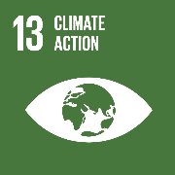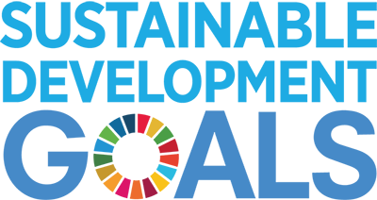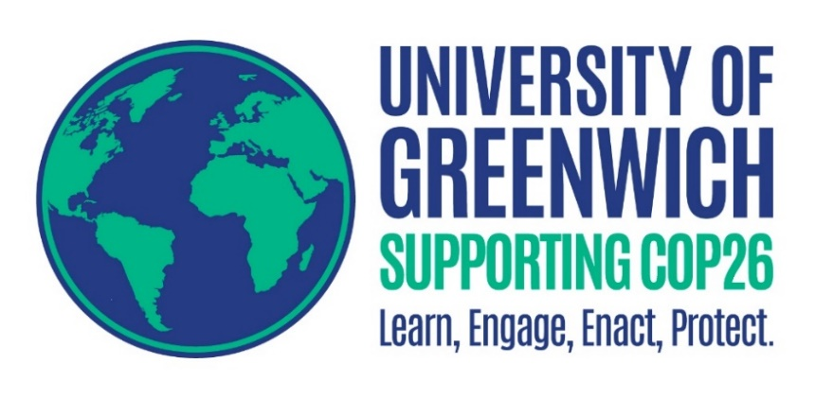

COP26 will bring together leaders and experts from around the World to discuss and agree actions on how we can avoid a climate crisis.

Here at Greenwich, we are proud of those involved in tackling these issues. Read on to find out how:

**Sustainability Leaders**

We all have the **power** to make a positive **difference**. By working together and sharing knowledge, we will create change.

*Photograph/selfie of yourself in this box please. If you cannot add one in, please attach it as a separate file (delete italicised text)*

*Name:*

*Department/Faculty/Directorate/Course & year*

*Email contact:*

*Research website (if applicable):*

*Years experience/a bit about yourself: (delete italicised text).*

**My Work:**

***Please summarise your research/project/work and why it is important to climate action, carbon reduction and/or COP26 and sustainability.***

***Title of the work:***

*Please include a clear, crisp and concise description of the work you want to showcase. Include any notable impacts, challenges and where you can see your work progress into the future.*

*Must fit this box (delete italicised text).*

*You can include a photograph if you wish here too. (Attach it as a separate file if struggling).*

**My project/research/initiative/work primarily relates to Sustainable Development Goal (SDG) and strongly contributes to: *(****please include up to three****)*** *E.g. SDG 13 Climate Action, and supports SDGs 2, 5 & 17 ((please delete italicised text)*

[***If unsure click here***](https://sdgs.un.org/goals)