Accessing the Dashboard through the PAS Dashboard Repository

Step 1.
Log into the portal and navigate to the ‘Staff Services’ page.
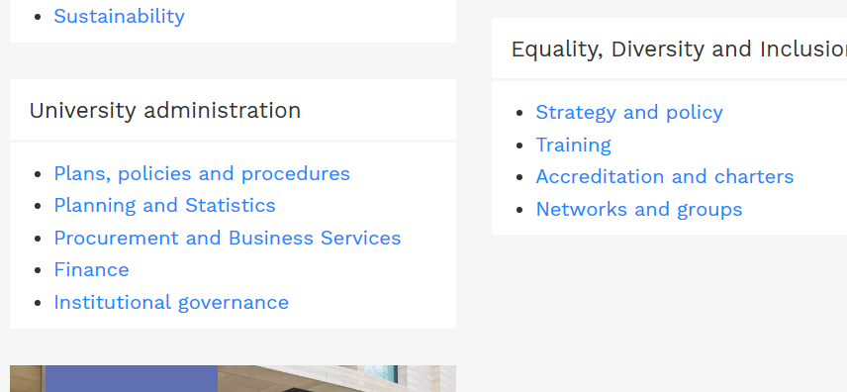
Step 2
Acess Planning and Statistics intranet (link at the bottom left of the page)

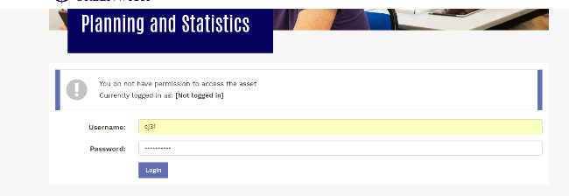
Step3
Log in to the Planning and Statistics Intranet using you normal log in details.

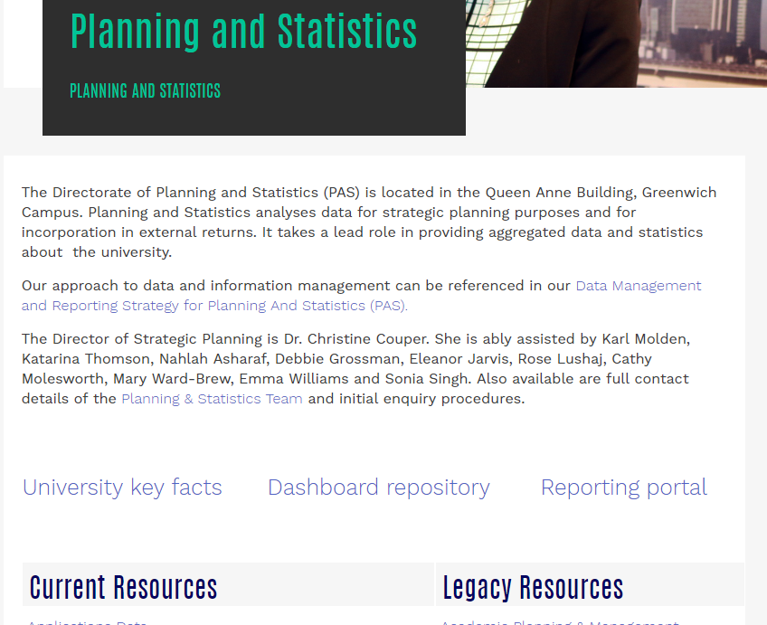
Step 4
Access the Dashboard Repository’

Step 5
At the Bottom of the Page is are two dashboards under the title

Value Added Project

Addressing Student Attainment Using Inclusive Curriculum Design and Value Added Metric
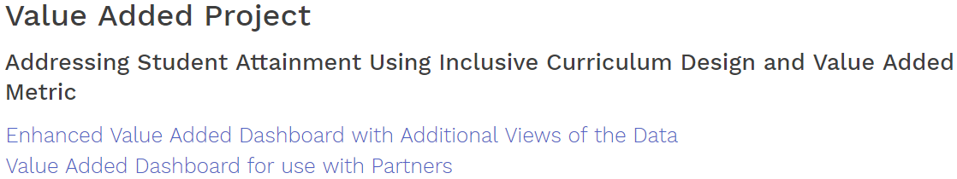
This dashboard uses our data. It is the dashboard that was used during the train the trainer session by the Kingston team. It does not include additional analysis by the Greenwich project team.
The enhanced VA Dashboard uses our data but contains a range of additional visualisations. We have incorporated the comments made by trainees at recent project events such as the inclusion of a glossary and an introduction to the Value Added methodology and the colour scheme.

