Please login into the University Portal at https://portal.gre.ac.uk using your University username and password
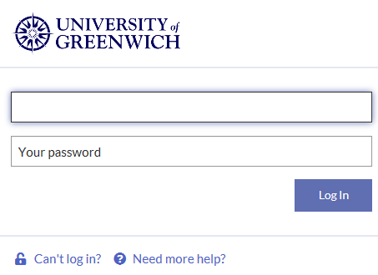

Open the “Research” tab

And click on the link “PGR attendance and Engagement Monitoring” for your Faculty
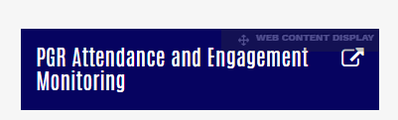
This will open in a new window the Moodle page for your faculty “PGR Attendance and Engagement Monitoring” course
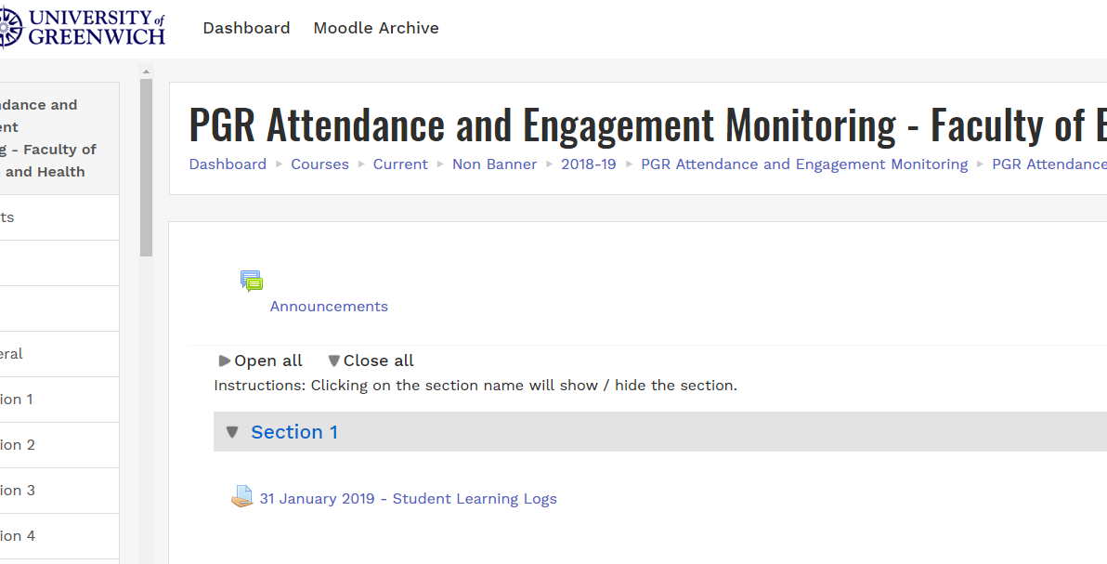

Select the relevant link to submit your learning logs and then click on “Add submission”
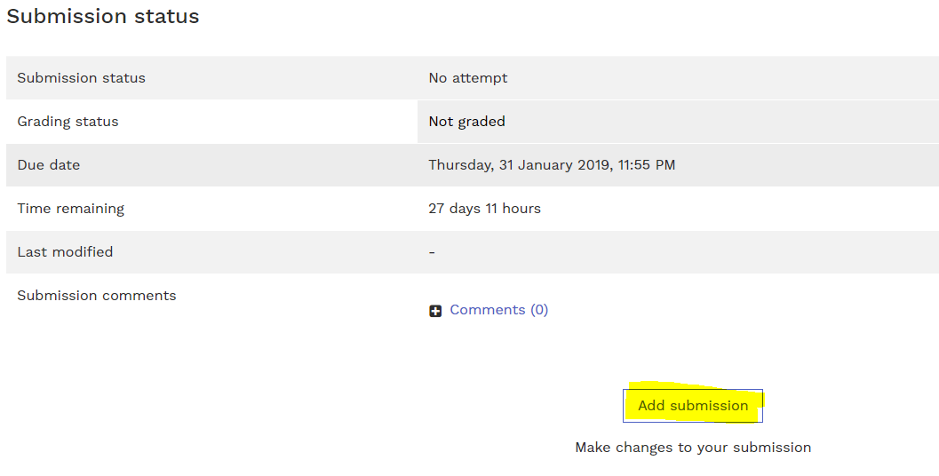

Thick the “This assignment is my own work” box and upload your file by dragging and dropping it
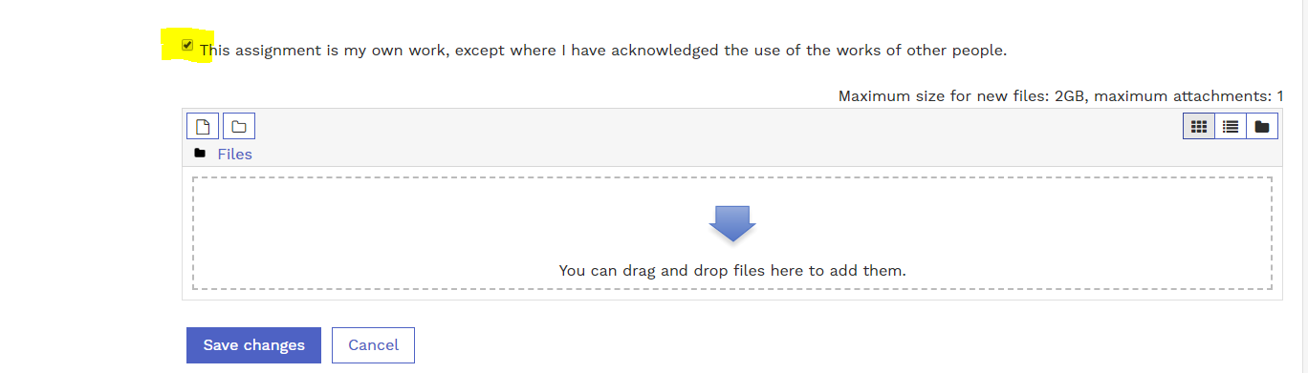

or by searching on your files
Then click on “Save Changes” and your document will be uploaded into Moodle.

